ECO RECYCLING STATION
E-WASTE ®
Televisions - Computers - Monitors
Printers - Laptops - Keyboards
Speakers - Mouse

USED OIL – ANTIFREEZE ®
20 LITERS (5 Gallons) PER VISIT
Used motor oil MUST NOT contain any foreign substances.
OIL CONTAINERS ®

COOKING OIL ®

USED OIL FILTERS ®
Metal Oil Filters only

BATTERIES ®

HOUSEHOLD HAZARDOUS WASTES ®

PAINT ®
Paint - Stain - Spray cans
(empty or full)

CARDBOARD ®
Clean – Flattened - Dry
NO Waxed Cardboard

PROPANE TANKS ®

FLUORESCENT LIGHT BULBS ®

® = RECYCLED ITEMS
NR = ITEMS ARE NOT RECYCLED

2020

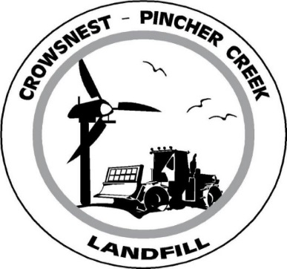
OUTSIDE AREA
BINS

Construction/Demolition Debris & Shingles (NR)

Tires ® – all sizes

Metal ®
Bicycles - BBQ’s - Pipe - Culverts
Culverts - Farm Equipment
Lawnmowers - Motors
All fluids must be removed and fuel tank purged & punctured
Wire & Cable, Clean Tin Cans
Barrels – must be open on one end & purged
Wood ®
Tree stumps - Branches
Timbers - Boards
Creosote or Preserved Wood

Household Waste (NR)
Food Waste
Paper – Plastics
Non-recyclable Cardboard
Small Plastic Electrical Appliances
Glass – Ceramics
Mattress/Box Springs
Furniture

APPLIANCES ®
Washers - Dryers - Stoves – Microwaves
Dishwashers & Freon Units
There is a $20.00 charge for refrigerators, freezers, air conditioners and anything that contains Freon.
CHILDREN AND PETS ARE NOT ALLOWED OUT OF THE VEHICLES

www.crowsnestpinchcherlandfill.com

OTHER AREAS
ASHES (NR) (cold)
In designated drop off location

CHEMICAL SHED
Pesticide and herbicide containers ®
(Triple rinsed and cut)
Bale Twine ® Bagged in clear plastic bags (NO Bail Wrap)
(West side of Chemical Shed)

MSW LANDFILL (NR)
Commercial Loads
Dump Trailers
Silage Bags
Untreated Grain Dust

CONCRETE & ASPHALT ®

PROHIBITED WASTES
The following wastes will not be accepted:
Liquids (including water)
Gasoline, Kerosene, Camp Fuel
Toxic Hazardous Waste
All Carcases
HOURS
Monday thru Saturday
8:00 am – 5:00 pm
CLOSED: SUNDAYS & HOLIDAYS
PHONE 403-628-3849 Ext #1
FAX 403 628-2258

